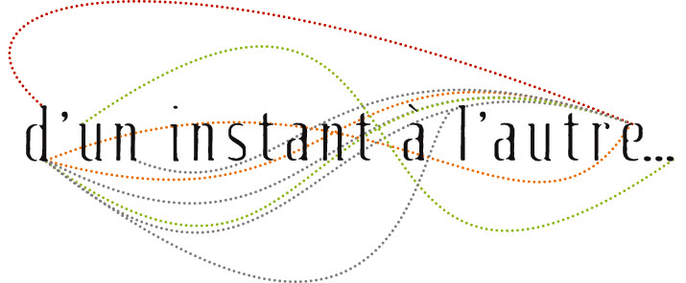
Professional workshop
Voice movement
with Christine Bertocchi

Dates
From July 24th to july 28th, 2017
30 hours — 5 days

Schedule
From 9:30 a.m. to 12:30 p.m. and from 2:00 to 5:00 p.m.

Registration
contact@uninstantalautre.com
+33 (0)6 25 11 20 29

Location
In the village of Quincerot (Côte d'Or), France. At the Compagnie D'un instant à l'autre's work studio.

Participants' profiles
Singers from all music backgrounds, actors, music teachers, choir directors.

Teaching content
Movements exploration brought into play during vocal emission. Furthering the work of the Feldenkrais Method so that to gain a better bodily organisation in support of voice technique and each participant's expression. Developing voice practices which will enable the widening of participant's vocal range. Collective practice will alternate with individual concrete implementation of pieces chosen from one's familiar repertoire.

Teaching tools
- breathing and physical exercises lying on the floor, sitting down and standing up (Feldenkdrais Method)
- movement of the suspensory muscles of the larynx, jaws, tongue and lips for a more flowing and accurate enunciation
- ranges exploration (voice in the head/voice in the chest)
- anatomy of the vocal apparatus
- relationship between gestures and vocal intentions
- postural organisation for a healthy vocal emission
- connections between spoken voice-singing voice
- resonators' exploration
- playing with different voice placements and their « displacements »
- coordination body/rhythm/voice
- oral transmission, imitation games
- implementation on individual repertoire (song, lieder, spoken text,...) chosen by each participant

Each day we will take the time to assess our work so that to identify everyone's progresses, expectations, needs.

Christine Bertocchi's biography
Christine begins performing on stage in 1989 for singing and theater shows, directed by Patrick Font while still training at the CNR in Grenoble and in various workshops. Starting from1992, her interest takes her toward multidisciplinary works (theater, dance, singing) and she begins to work for choreographers and theater directors, such as Bruno Meyssat (1993-1999).
Christine pursues her training in lyrical singing, as well as taking part in a contemporary vocal music workshop at the Centre Acanthe (2002), led by Françoise Kubler. A certified Feldenkrais practitioner since 2000, Christine also trained in voice anatomy and physiology with phoniatrician Guy Cornut and Blandine Calais-Germain.
Co-founder of the non-profit organization Mercoledi & Co (1996 to 2001), she develops a unique body of works via performances in the form of reading-concerts (Michaux, Wedenski, Kafka), readings of contemporary authors, and performances in music improvisation.
Since then, she's developing a duet with bass player Eric Chalan, titled « à mesure... » (co-written with Ghislain Mugneret/texts and Guillaume Orti/music). Christine is also regularly invited by contemporary composers and authors.
Since 2005 she works both in Bourgogne where she founded D'un instant à l'autre company, and Paris where she still collaborates with music-improvisers, composers and authors.
Christine teaches vocal techniques, vocal improvisation, musical theater and ways to integrate body and stage work (Certified Feldenkrais® practitioner since 2000) in professional training settings for musicians, singers, dancers or actors (Harmoniques in Paris, Orsay CFMI, ARIAM, CNFPT, Afdas training sessions, Opera Houses), throughout France and beyond.

d’un instant à l’autre
Association loi 1901
1, route de Châtillon - 21500 Montbard
N° Siret : 483 308 797 00024 - Code APE : 9001 Z

N° de Licence d'Entrepreneur de Spectacles : 2-1064262
N° d'agrément formation : 26 21 02705 21

